Customer Segmentation Analysis – Istanbul Shopping Malls
This dataset contains shopping information from 10 different shopping malls between 2021 and 2023. We have gathered data from various age groups and genders to provide a comprehensive view of shopping habits in Istanbul. The dataset includes essential information such as invoice numbers, customer IDs, age, gender, payment methods, product categories, quantity, price, order dates, and shopping mall locations.
Overall totals: 1,000 invoices · 2,981 units sold · revenue 2,365,367.77 · average invoice value 2,365.37

Q1. How is the shopping distribution according to gender?

Gender | Invoices | Share of invoices | Units | Share of Revenue | Share of units
Female | 620 | 62.0% | 1,853 | 59.56% | 62.2%
Male | 380 | 38.0% | 1,128 | 40.44% | 37.8%
Total | 1,000 | 100% | 2,981 | 100% | 100%

Answer: Women make up 62% of invoices and men 38%. Women shop far more often than men.
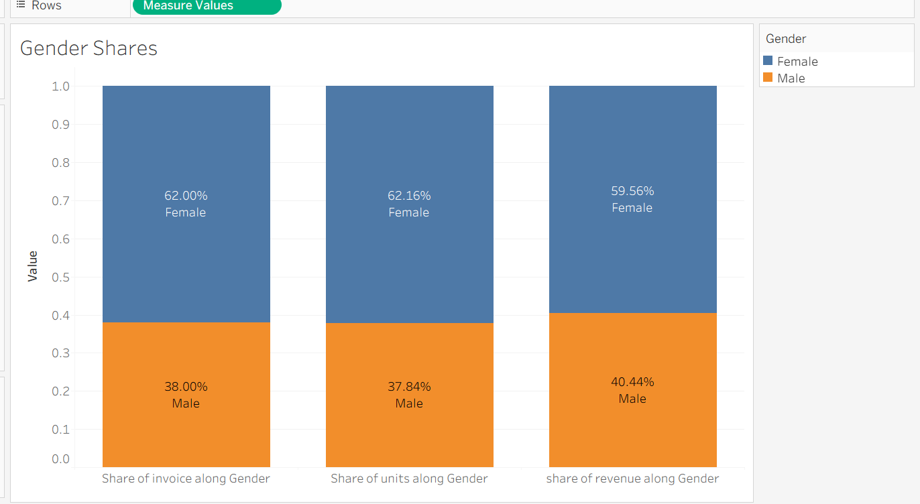

Q2. Which gender did we sell more products to?

Gender | Units sold
Female | 1,853
Male | 1,128
Answer: Female. We sold 725 more units to women than to men.
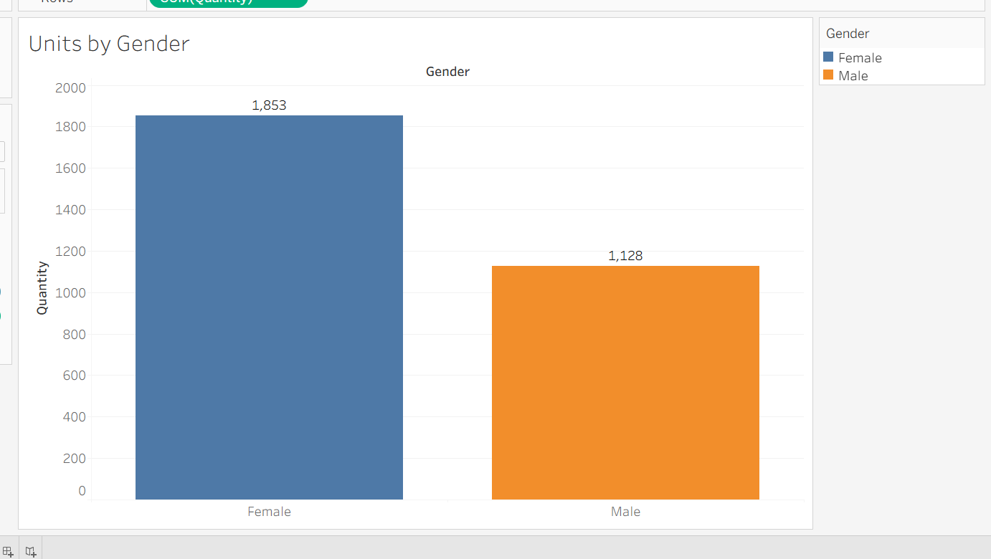

Q3. Which gender generated more revenue?

Gender | Revenue | Share of revenue | Average per invoice
Female | 1,408,881.11 | 59.56% | 2,272.39
Male | 956,486.66 | 40.44% | 2,517.07
Total | 2,365,367.77 | 100% | 2,365.37
Answer: Female generated more revenue (about 59.6%). Men spend more per invoice, but women visit more often, so they lead in total.
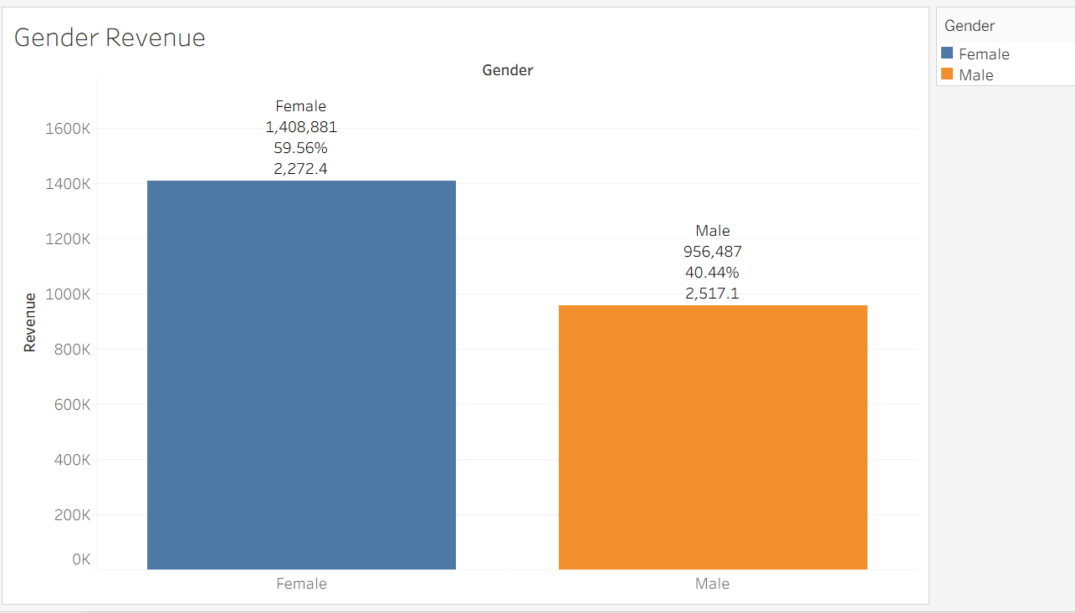

Q4. Distribution of purchase categories relative to gender
Share of each gender's invoices by category (%):
Category | Female | Male
Clothing | 34.0 | 33.4
Cosmetics | 16.1 | 14.5
Food & Beverage | 12.1 | 13.2
Toys | 10.5 | 10.3
Shoes | 9.8 | 11.1
Souvenir | 7.3 | 5.5
Books | 6.1 | 7.6
Technology | 4.0 | 4.5
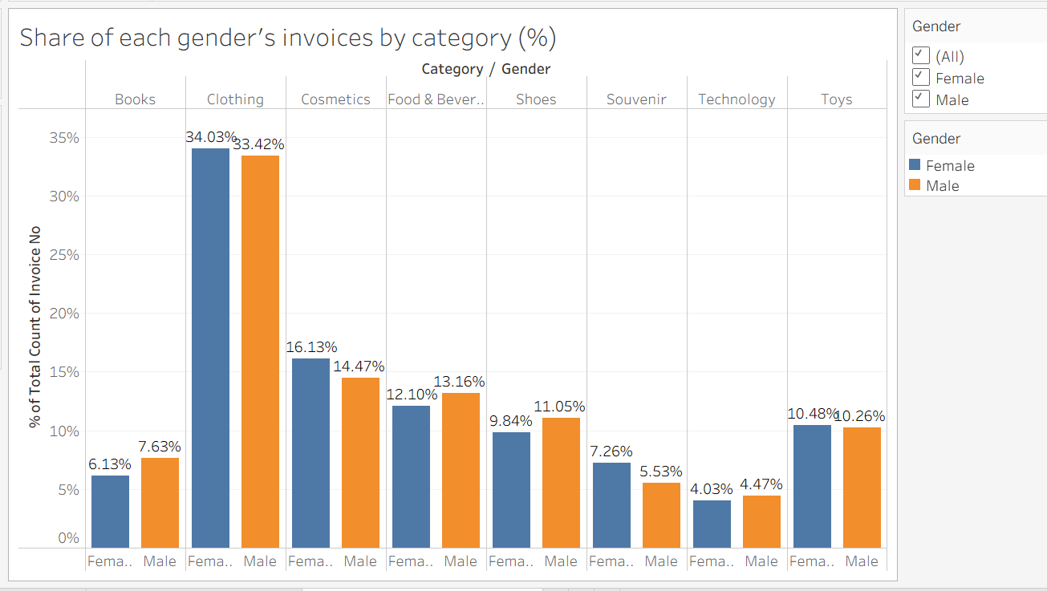
Revenue by category and gender:
Category | Female | Male
Clothing | 650,573 | 397,606
Shoes | 381,708 | 303,686
Technology | 286,650 | 206,850
Cosmetics | 44,767 | 24,315
Toys | 28,529 | 13,834
Books | 5,999 | 4,575
Food & Beverage | 4,121 | 2,594
Souvenir | 6,534 | 3,026
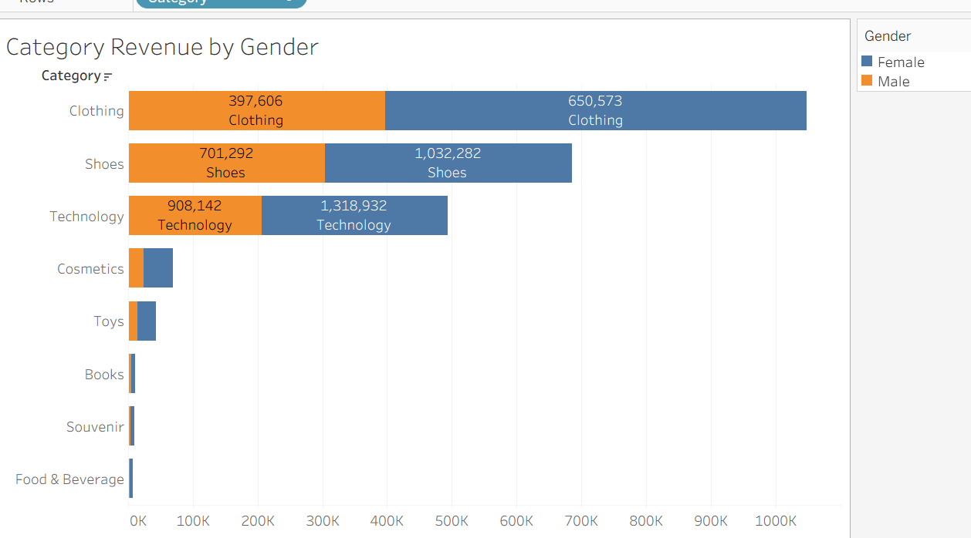
Answer: The category mix is almost identical for women and men (chi-square p = 0.89, not significant). Women lead in revenue in every category only because they make more purchases.

Q5. How is the shopping distribution according to age?
Age groups: 18–25, 26–35, 36–45, 46–55, 56–69 (ages in the data range from 18 to 69).
Age group | Invoices | Units | Revenue | Share of revenue
18–25 | 159 | 479 | 356,153 | 15.1%
26–35 | 185 | 553 | 402,877 | 17.0%
36–45 | 203 | 618 | 473,663 | 20.0%
46–55 | 174 | 531 | 394,979 | 16.7%
56–69 | 279 | 800 | 737,696 | 31.2%
Answer: Shopping is spread across all ages, with the 56–69 group the largest by invoices (279) and units. Note this band covers 14 years, versus 8–10 for the others.
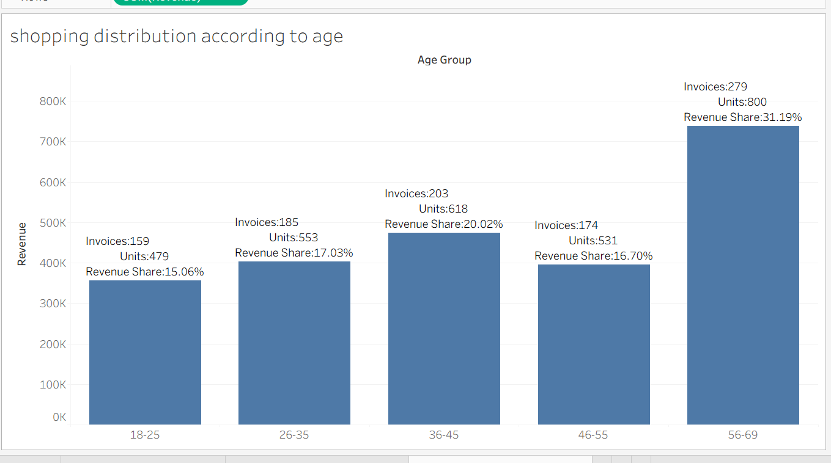

Q6. Which age category did we sell more products to?
Age group | Units sold | Share of units
56–69 | 800 | 26.8%
36–45 | 618 | 20.7%
26–35 | 553 | 18.6%
46–55 | 531 | 17.8%
18–25 | 479 | 16.1%
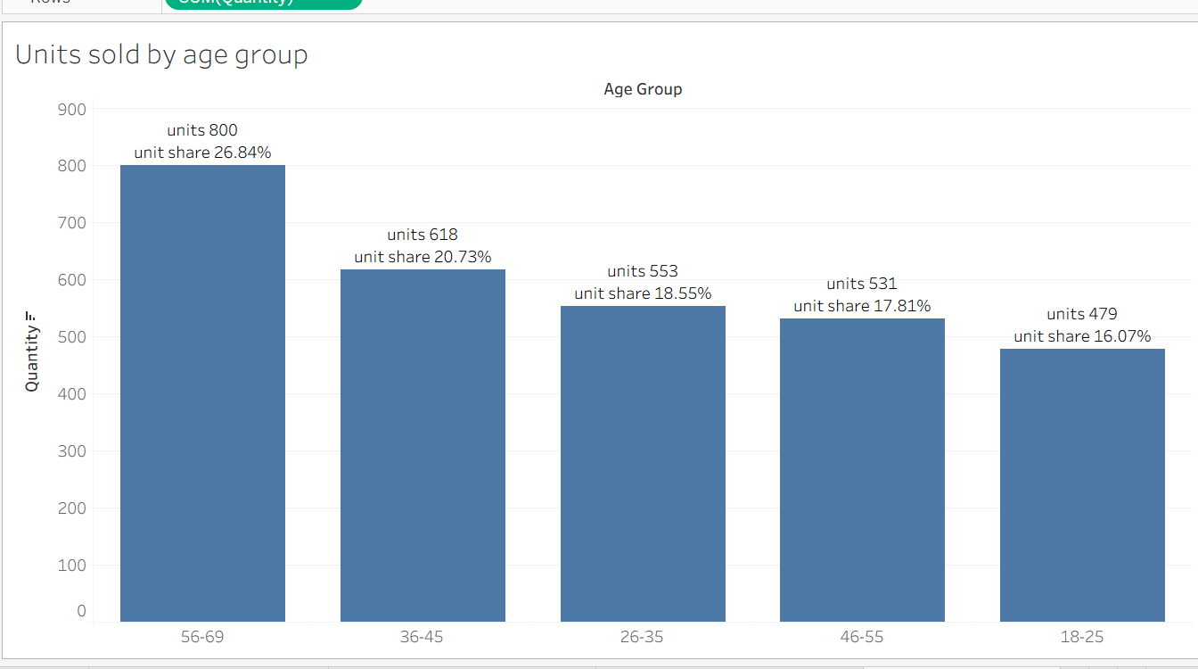
Answer: The 56–69 group.

Q7. Which age category generated more revenue?
Age group | Revenue | Average per invoice
56–69 | 737,696 | 2,644
36–45 | 473,663 | 2,333
26–35 | 402,877 | 2,178
46–55 | 394,979 | 2,270
18–25 | 356,153 | 2,240
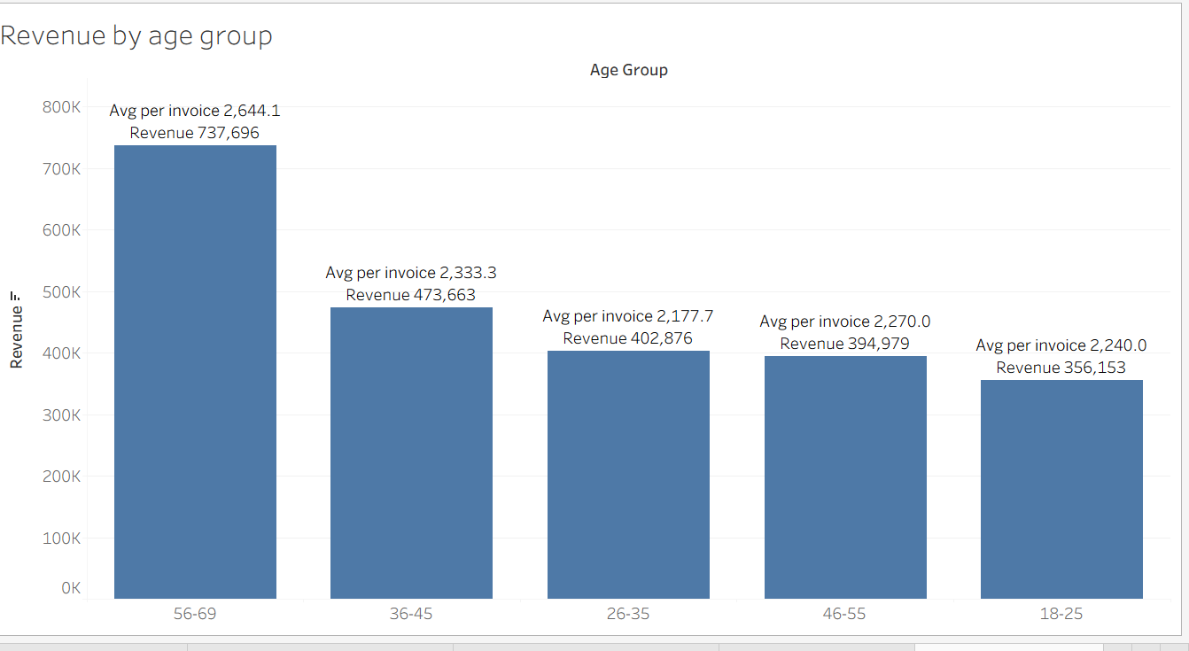
Answer: The 56–69 group, with 31.2% of total revenue and also the highest average invoice.

Q8. Distribution of purchase categories relative to age
Share of each age group's invoices by category (%):
Category | 18–25 | 26–35 | 36–45 | 46–55 | 56–69
Clothing | 37.1 | 31.4 | 31.5 | 36.2 | 33.7
Cosmetics | 15.1 | 17.3 | 15.3 | 16.7 | 14.0
Food & Beverage | 10.1 | 14.6 | 13.3 | 13.8 | 11.1
Toys | 13.2 | 7.0 | 9.9 | 8.6 | 12.5
Shoes | 5.7 | 11.4 | 11.3 | 9.2 | 12.2
Souvenir | 6.3 | 9.7 | 6.9 | 5.2 | 5.4
Books | 6.3 | 6.5 | 7.9 | 8.0 | 5.4
Technology | 6.3 | 2.2 | 3.9 | 2.3 | 5.7
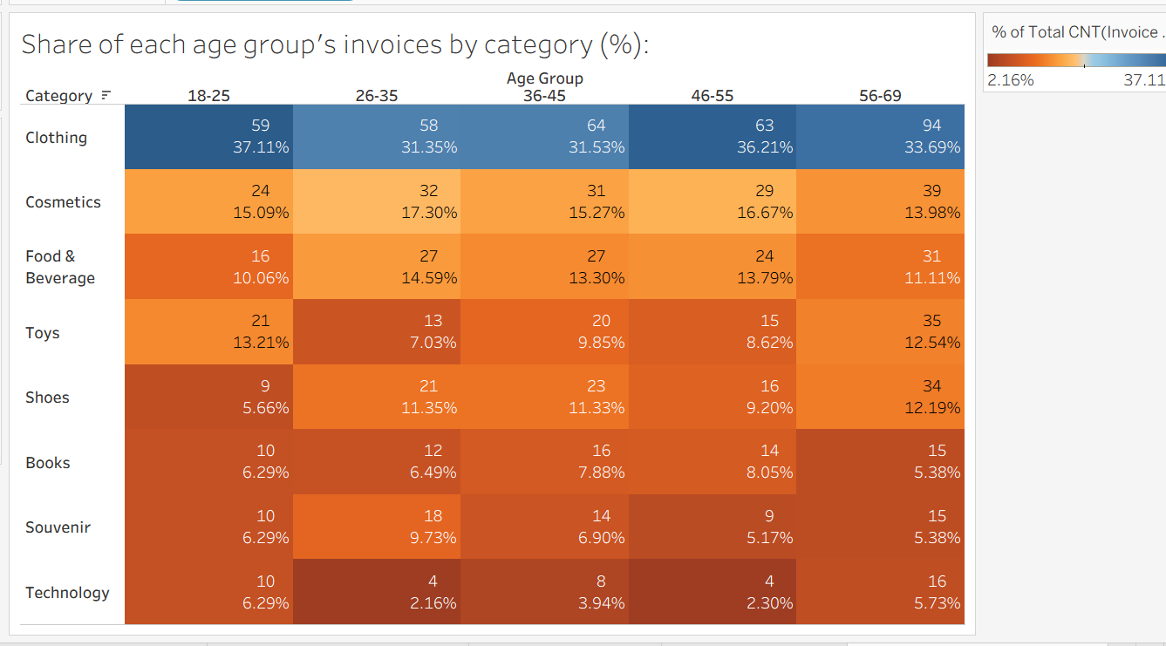
Overall category totals:
Category | Invoices | Units | Revenue | Share of revenue
Clothing | 338 | 977 | 1,048,179 | 44.3%
Shoes | 103 | 312 | 685,394 | 29.0%
Technology | 42 | 128 | 493,500 | 20.9%
Cosmetics | 155 | 473 | 69,081 | 2.9%
Toys | 104 | 324 | 42,363 | 1.8%
Books | 67 | 196 | 10,575 | 0.4%
Souvenir | 66 | 213 | 9,560 | 0.4%
Food & Beverage | 125 | 358 | 6,715 | 0.3%
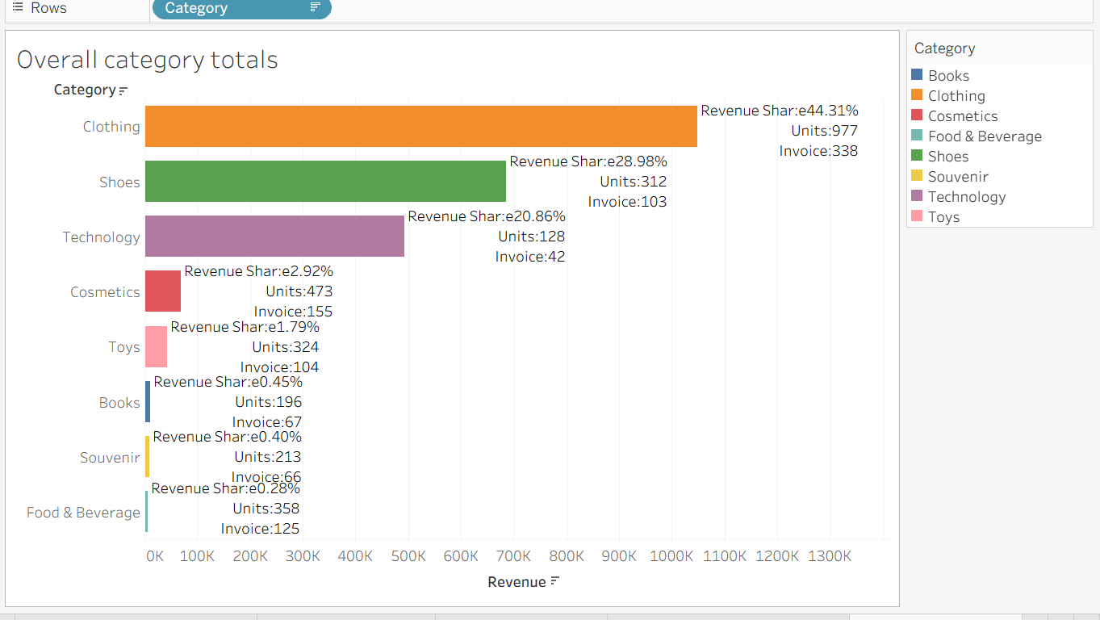
Answer: Clothing is the top category for every age group. Young (18–25) and older (56–69) customers buy more Toys and Technology, and 26–45 buy more Shoes. These differences are small and not statistically significant (p = 0.53). Clothing, Shoes and Technology bring in about 94% of revenue.

Q9. Does the payment method have a relation with other columns?
I tested payment method against each column using a chi-square test (ANOVA for numeric columns).
Column compared | p-value | Significant?
Gender | 0.604 | No
Age group | 0.362 | No
Category | 0.141 | No
Shopping mall | 0.456 | No
Year | 0.521 | No
Quantity | 0.589 | No
Age (ANOVA) | 0.436 | No
Revenue (ANOVA) | 0.290 | No
Answer: No. Payment method is essentially independent of the other columns (a relation is significant only if p < 0.05). Small non-significant leanings: ages 46–55 use cash most (47.7%), ages 18–25 use credit cards most (41.5%), and Emaar Square Mall is the only mall where credit card (49.1%) beats cash.

Q10. How is the distribution of the payment method?

Method | Invoices | Share | Revenue | Share of revenue
Cash | 420 | 42.0% | 1,041,240 | 44.0%
Credit Card | 366 | 36.6% | 770,273 | 32.6%
Debit Card | 214 | 21.4% | 553,856 | 23.4%
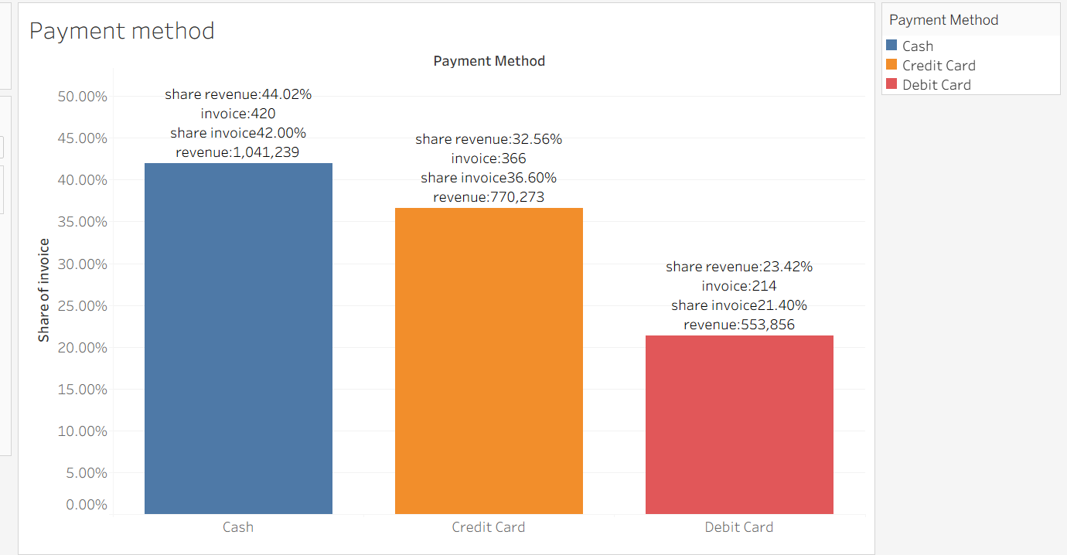
Payment mix by gender (%):
Gender | Cash | Credit Card | Debit Card
Female | 43.2 | 35.8 | 21.0
Male | 40.0 | 37.9 | 22.1
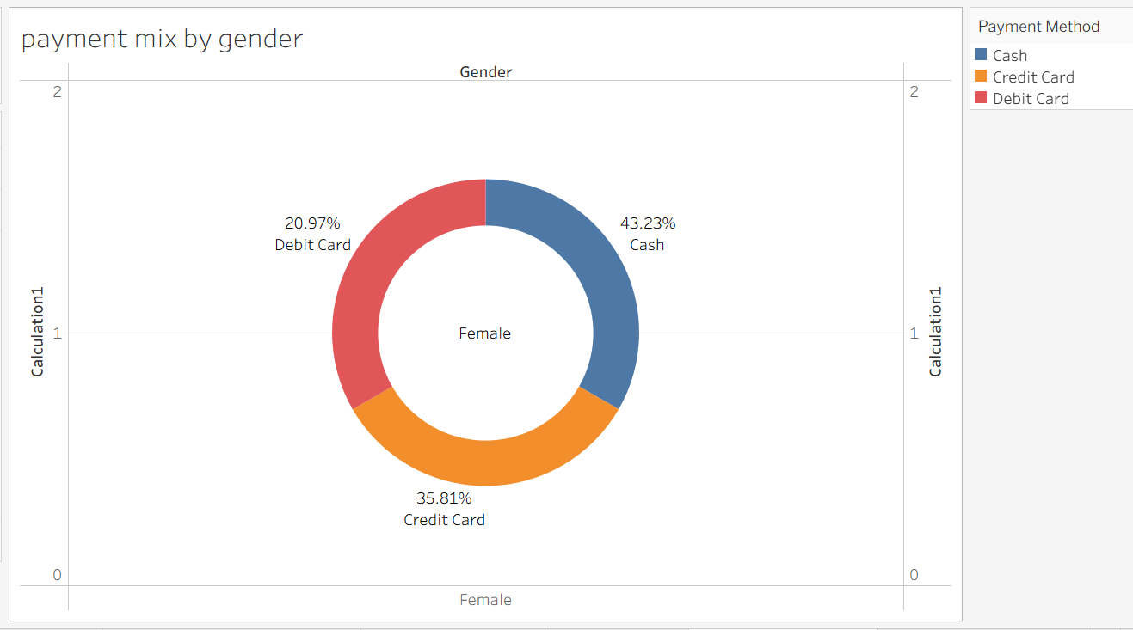
Answer: Cash is the most used method (42%), followed by credit card (36.6%) and debit card (21.4%).
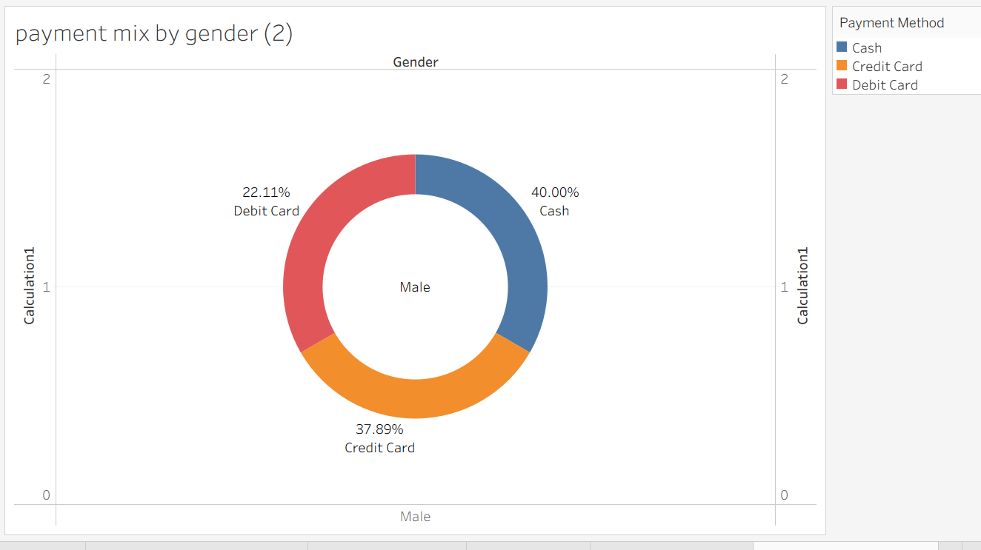

Q11. Insights and suggestions for the company
Top malls by revenue: Mall of Istanbul (528,002), Kanyon (377,836), Metrocity (336,084). Monthly revenue peaks in July (291,582) and is lowest in December (96,977).
- Focus on high-value categories. Clothing, Shoes and Technology drive the business, so put promotions, loyalty offers and prime floor space around them. Treat Food & Beverage, Books and Souvenir as traffic builders.
- Target the 56–69 segment. They are the biggest revenue source and spend the most per invoice. Premium Technology and Shoes bundles would suit them.
- Don't over-target by gender. Preferences are the same, but women are 62% of invoices. Grow male traffic with men's Clothing and Shoes campaigns.
- Upsell Cosmetics and Toys. They have healthy unit volume but only about 3% and 2% of revenue, so bundles or premium lines could raise their value.
- Learn from the top malls. Mall of Istanbul, Kanyon and Metrocity bring in 53% of revenue. Zorlu Center, Viaport Outlet and Metropol AVM have the highest value per invoice (about 2,800–3,100) but low traffic, so marketing there could pay off. Kanyon and Istinye Park have high traffic but lower value per invoice (about 1,900), which suggests upselling.
- Keep all payment methods and promote cards. Cash is still the most used method, so don't drop it. Card-linked offers could shift some of it toward cards.
- Plan around seasonality. Reinforce July with mid-year campaigns and lift December with a year-end push.

Data notes
- The file is a 1,000-row sample, so treat percentages as indicative.
- 2023 covers only January to early March, so don't compare it to full years.
- Revenue is dominated by price (Technology averages about 3,200 per item, Food & Beverage about 15), so units and revenue give different rankings.

